

**BRACT’s**  
**Vishwakarma Institute of Information Technology  
Department of CSE-AI**

(An Autonomous Institute affiliated to Savitribai Phule Pune University)



# Lab Manual

Data Science and Machine Learning

**Submitted by,**

**Vaibhav Vinod Chavhan**

SY

Semester II Academic Year 2023-24

**ASSIGNMENT NO: 3**

**Problem Statement -**

Apply appropriate ML algorithm on a dataset collected in a cosmetics shop showing details of customers to predict customer response for special offers.

**S/W Packages and Libraries used:**

For the following assignment, the interpreter used was Google Collab and the Primary Library used was-

* Scikit-learn: Scikit-learn offers a wide range of machine learning algorithms and evaluation metrics, enabling the implementation and evaluation of the KNN classifier for predicting customer responses to special offers.

**Theory-**

* Data Preparation:
  + Load the dataset using Pandas to a DataFrame, ensuring it contains relevant customer details and responses to special offers.
  + Preprocess the data by handling missing values, encoding categorical variables, and splitting the dataset into features (input variables) and target variables (customer response).
* Feature Scaling:
  + Standardize the features using StandardScaler from Scikit-learn to ensure all features are on the same scale, preventing any particular feature from dominating the model training process.
* Train-Test Split:
  + Split the dataset into training and testing sets using train_test_split from Scikit-learn. This ensures the model is trained on one portion of the data and evaluated on another to assess its generalization performance.
* Model Selection and Training:
  + Apply the K-Nearest Neighbors (KNN) algorithm from Scikit-learn to predict customer responses to special offers. KNN is chosen for its simplicity and effectiveness in classification tasks.
  + Train the KNN classifier on the training data, tuning hyperparameters such as the number of neighbors (K) if necessary.

**Applications:**

* Customer Relationship Management: Predicting customer responses to special offers can aid in personalized marketing strategies, enhancing customer satisfaction and loyalty.
* Sales Optimization: Understanding customer preferences enables the optimization of product offerings and promotional campaigns, leading to increased sales and revenue.

**Limitations:**

* Data Quality: The effectiveness of the predictive model heavily relies on the quality and representativeness of the dataset. Inaccurate or biased data may lead to unreliable predictions.
* Model Complexity: While KNN is simple and intuitive, it may not perform optimally with large datasets or in high-dimensional feature spaces. Other algorithms like Decision Trees or Random Forests could be explored for better performance in such scenarios.

**Working:**

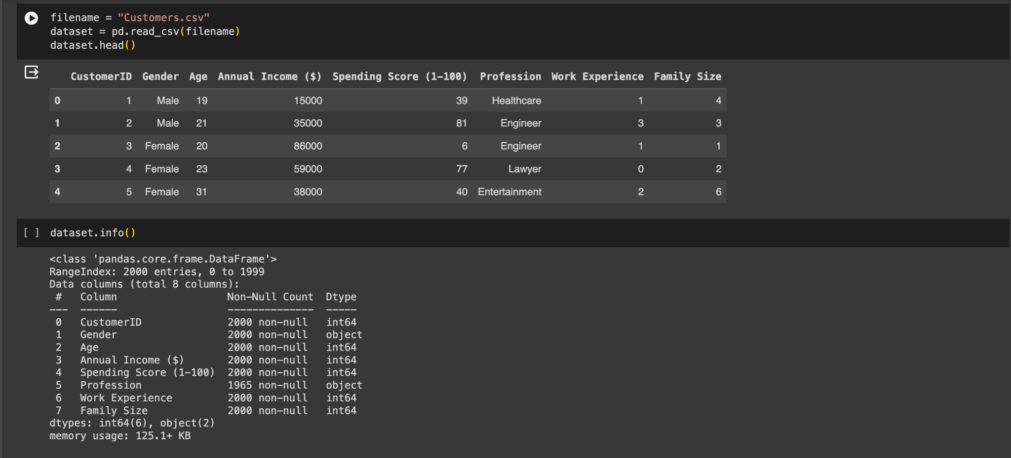

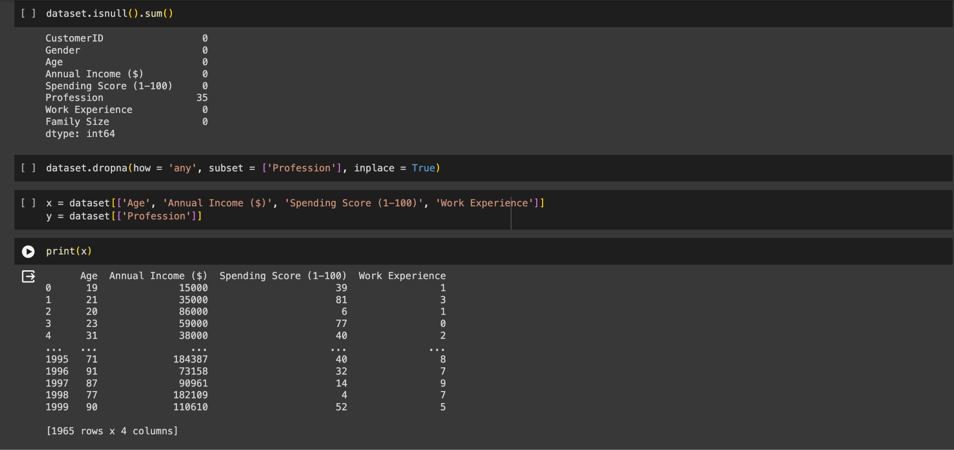

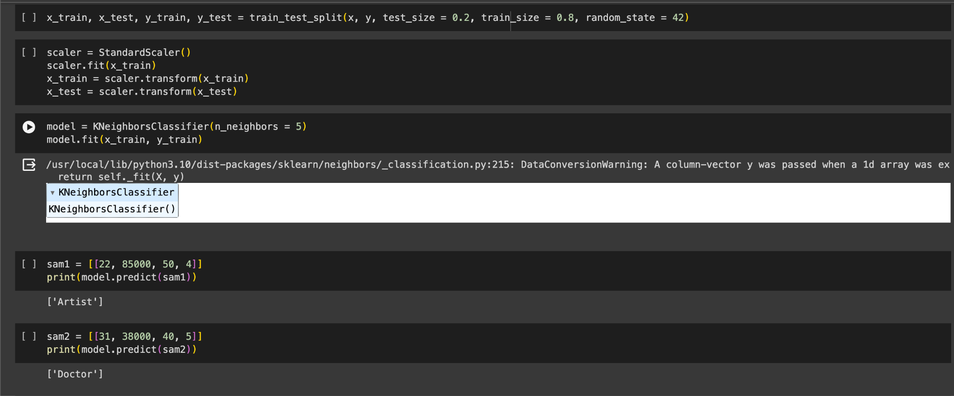

**Conclusion:**

By following this methodology and understanding the applications and limitations of the assignment, practitioners can effectively apply machine learning techniques to predict customer responses in a cosmetics shop setting, leveraging the capabilities of libraries like Pandas, NumPy, and Scikit-learn.